Weekend Spelunking at Whirlpool

**6:00 P.M.**

Breathless and relieved, we’re finally nearing the exit. The 4 ½ hour-long trek back has been unexpectedly harder. Climbing up through the toothed cavern forced strange contortions from my inflexible frame, and my neck is stuck in a crooked lean to the left. The group huddles, absorbing the moment of rest, in a small chamber, probably about 20 feet from the entrance. Our guide, Mark, coughs softly and explains why we have halted.

“We can’t find Lance and Matt,” he says.

**10:30 A.M. That Morning**

The sun is shining and the breeze is mild for a Saturday morning in February. Sarah and I double check our packs for required spelunking necessities: snacks, drinks, clean clothes, and a notepad. The instructors are sure to bring the technical climbing gear, like the headlamps, helmets, pads, and safety kits. Gear in tow, we eagerly get into our car and head to the SLC to meet the rest of the Extreme Caving Extravaganza team.

There are 13 of us, three enthusiastic leaders, Mark, Zack, and Becky, and the rest of the team Lance, Matt, Rebecca, Christina, Julie, Anu, and a pair I only know as the married couple, Sarah, and me. Mark is the most experienced caver, and with his caving expertise, competent mud blemished boots, and caving pack that’s filled with more than Cheese-its and Gatorade, he will be my first call if I get stuck in a cave hole. Our group is going to the Whirlpool Caves in Austin. Most of the trip will be spent crawling through stony vessels of sharp rocks on our hands and knees. Fear of small spaces should be abandoned in Waco.

The leaders explain the rules; no weapons, no drugs, no alcohol, and no leaving the group.

Finally, we’re ready to load up and get on the road. This is the plan: leave for Austin, stop for food, go caving, go to Freebirds, then drive back to Waco. Everyone is excited about caving, but most of us can’t stop talking about the epic Freebird burrito.

**2:30 P.M.**

We park underneath a bridge next to the paved back road.

“This is where it’s at?” I ask.

“Yeah,” says Zack, “It looks kind of shady, doesn’t it?”

Admittedly, it does. There are two concrete bridges, displaying graffiti, with an unkempt forest area beyond them. We unload and prepare for the main event. I put on a helmet, headlamp, knee pads, elbow pads, and secure my pack tightly on my back.

I don’t know what I expected; maybe a large half-circle cave opening that we would all skip into and tour casually. Instead, the entrance is a 2x4 thick metal hatch that opens like a sewer flap to a nine foot ladder that takes you into the entry room of the cave. We all couldn’t help but feel like ninja turtles.

When my turn comes, I slowly lower myself through the hatch, securing foothold on the top rung of the ladder, and descend cautiously into the black abyss. Reaching the bottom I yell, “Clear.”

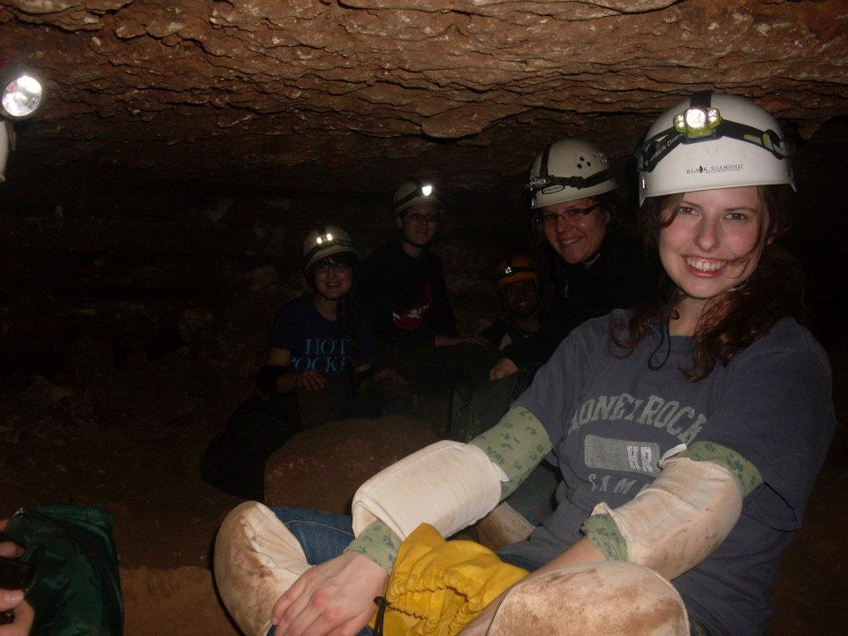I crouch down in the low space and feel my way to a sitting spot next to Becky. The rest of the extreme cavers continue making their way, one-by-one, down the ladder and into the underground pocket. When everyone is in, we move closer together, awkwardly adjusting out positions in an effort to keep rock shards from piercing our legs. Mark climbs back up the shaky ladder to close the metal lid, the only entrance and exit to the cave.

The whispers of the wind are silenced by the thundering boom of its close. The dank hole beneath the surface is enveloped in perfect darkness for a split second before a headlamp clicks and illuminates the underground rock chamber. I jerk forward when I feel a droplet of water fall on my exposed shoulder. I click on my headlight and see the hopeful dew drops clinging to the dripping rock formations. The rock ceiling glimmers in the low-light with tiny flecks of white like it is studded with tiny diamonds. I bend my neck backwards to view the jagged roof, but I quickly knock forward when my head hits the jutting rock behind me. I haven’t been this thankful for a helmet since learning to ride a bike.

Before I have time to inspect further, Mark steps off the entrance ladder and begins to speak. I watch my fellow extreme cavers adjust to their new surroundings. Some eye the vault with slight trepidation, some with readiness and excitement. They listen as Mark explains the process required to move forward. We will go through in a line, with about a five-foot distance between each caver. If you lose sight of the person in front of you, yell at them to slow down.

As Mark continues, I assess my reaction to this newfound shelter. I am not panicking. I am eager to begin tunneling through the caverns. Then, Mark tells us about the birth canal or “the squeeze” as the politically correct instructors call it. This is the tightest passage in the cavern. It is a short stretch of tunnel that must be inched through using wormlike dexterity. We have a couple hours to ponder this new information, because the birth canal is located far into the cave. The chances of getting stuck are slim, but anything can happen in the hollowed walls of the cave.

“Alright, let’s go!” Mark orders.

And now, with something new to fear, we adjust our knee and elbow pads, secure our helmets, and click our headlamps to the floodlight setting. One after the other, the team disappears into the small opening at the back of the cave’s entrance.

I’m lucky to be at toward the end of the extreme caver line with only Sarah and Zack behind me. Julie journeys directly in front of me. Julie is my connection to the rest of the group. If I lose sight of her, I lose sight of the entire team. I braid my long, dark hair to hang over my left shoulder and tighten my helmet in preparation for the descent in the cave. Sarah smiles eagerly and says, “Let’s go.”

Julie fades into hole in the rock, and it’s my turn.

“Clear,” shouts Julie. The cavity absorbs the sound, and her voice is muffled. Now that she has distanced herself far enough to avoid potential rocks that may slip from my entry, I can begin. The opening appears to curve to the right and into a rocky downward spiral of extending rock. I lower myself into the crevice feet first and scoot down the slanted orifice. My elbows and the heels of my feet push me forward as the stone passage narrows, and I can no longer sit up without banging my helmet against the cave ceiling. Within a few meters, the inclined tunnel levels, and for a few feet I am able to lift my head. There are no more dew drops or glittering spots hanging onto the jagged rock. I find myself wishing the whole cave was bedazzled like the entrance as the brown rock darkens. We’re even farther away from the surface of the Earth, and the temperature has risen to a stale 70 degrees. The air is still, the only waft you feel is breath against your skin. The effect is not suffocating, but calm.

Julie is visible once again, only a few feet in front of me, she has shifted position to better maneuver through the twisting crawlway. She is now lying on her stomach with her helmeted head leading the way. I follow suit and rotate 180 degrees and onto my stomach. The passage has constricted considerably. The only way to move is to army crawl frontward, mindfully correcting the shifting pads on your knees. I continue pushing onward, carefully angling my helmet to take the blow of any unexpected rock. For a while, all I hear is the shuffle of bodies and small coughs of exertion.

Zack interrupts the quiet to explain some of the small cave formations. Inside the Whirlpool Caves we will see stalactites and stalagmites. These formations occur in limestone caves. The stalactites hang from the cave top like icicles. To me they look like upside-down candles with hardened wax waiting to be melted. The stalagmites stick up from the cave bottom. Zack makes it easy to remember, “the mites go up and the tites go down.”

Zack fills in more pauses as we go through the stony course with song and joke. I hear the married couple in front of Julie feeding each other words of encouragement, “Good job sweetie!”

Sarah is behind me shouting with every inch she loses sight of me, “Slow down!”

It is easy to get lost in the redundant scenery, and I lose track of how far or how long we have been moving. Intermittently, I am able to raise my head high enough to crawl on my knees. Mark is the only one who really knows where we are going or where we are at. The rest of us blindly follow.

**4:00 P.M.**

Eventually the tunnel begins to widen, and I crawl into a jagged, uneven rock chamber called the Travis County room. The Travis County room is the largest cave room in Travis County, and provides enough space to sit all thirteen of us. I see the headlamps of my fellow cavers sitting clumsily in a circle, taking sips of their water bottles and snacking. I know we’ve been moving a long time by the way my stomach is growling.

Sarah and Zack crawl in after me, exhaling in relief as they lean against the rock wall stretching out their legs. Zack pulls his water bottle out of his pack and takes a long dramatic sip. He wipes his mouth sloppily with the back of his hand, looks at me and Sarah and says, “Do you ever remember not being in the cave?”

I answer, furrowing my eyebrows in recollection, “I’m not sure, it seems more like a dream to me; the surface.”

“We’re cave people now,” he laughs.

Everyone continues to chit-chat for a while. I talk to Julie, and she mentions her fears about finally reaching the cave’s birth canal. I chuckle in agreement. Mark speaks up and addresses the team.

“There’s something I like to do here in the Travis County room,” begins Mark.

He says we are going to stop talking and experience silence, and we are going to turn off our headlamps and experience darkness.

“People forget to just sit and be silent every day,” he says. “Just for one minute, sit down, and listen to the silence, so that’s what we are going to do.”

Slowly, we click off our headlamps. The last light dies, and the darkness eats all the tangible beings in its way until there is nothing but void black space. The initial effect is jarring, but it is immediately replaced with a withdrawal from the physical space, and it no longer matters if my eyes are opened or closed. Then, I find myself mentally panicked. If this is the only time I’ll be meditating in arena of pure peace and quiet, what should I ponder? Something existential maybe? Something metaphysical?

Then, I stop thinking. I take Mark’s advice and listen to the silence, and for once, silence says nothing.

I don’t realize how amplified my hearing has become until I detect the bluesy melody of a phantom harmonica. The soothing notes ease me awake. Taking one last breath I turn my headlamp back on and reacquaint myself with reality.

**5:00 P.M.**

We finally reach the birth canal. I am still not sure if I’m ready for the squeeze, but with the way the leaders have been building up the canal, I almost expect something magical on the other side. Maybe we have actually army crawled to the center of the Earth.

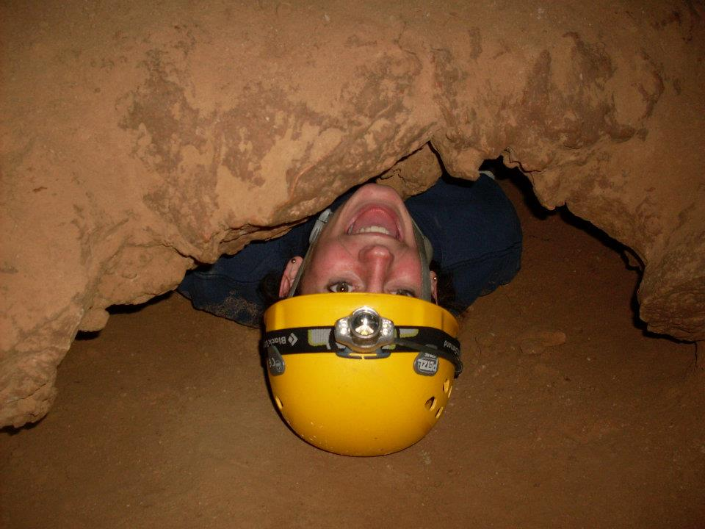

I gather my courage and inch through the passageway as it begins to narrow. I finally reach the birth canal. It is my turn to hold my breath, suck in stomach, and worm through the squeeze. I take off my helmet, so I can push it through ahead of me. Apparently, our heads will get stuck if we keep the headgear on. Lying uncomfortably on my stomach with one hand forward pushing my helmet through and one hand against my side, I begin to edge slowly through the six-foot passageway to the other side of the canal. My movement is slow, and the enclosing channel leaves only centimeters of space between my small frame and the tunnel wall. When venture begins to feel suffocating the sound of my team members’ encouragement reminds me that they won’t leave me there if I get stuck, so I stop worrying and keep worming onward.

I exhale the breath I didn’t realize was trapped in my lungs as I pull myself out of the canal. I am not at the center of the Earth, and there is no magical spring. Nonetheless, I feel proud that I conquered the birth canal, and I do not have to do it again. Then, Becky graciously reminds me there is only one way in and out of the cave.

**6:00 P.M.**

Mark bites his dirt-stained nails worriedly deciding how to proceed in recovering Lance and Matt. “I need a volunteer to go back and find them with me,” says Mark.

Lance and Matt went ahead of the group to take a harder path. They were supposed to be waiting for us in this room, but they are not here. Most likely, they have taken a wrong turn; we all pray that it is not anything worse.

Mark, Zack, and the husband leave to search for Lance and Matt. This leaves the girls waiting nervously on the cold floor in the suddenly claustrophobic cave. We mask our anxieties with some girl talk. Becky asks one-half of the married couple how they met. She answers with a cute story about flowers, butterfly kisses, and proposals.

Sarah suggests we turn off our headlamps to preserve the remaining light we have. Eventually, the room is silenced. Everyone shifts uneasily in the dark. We don’t want peace and quiet anymore. All we want is the sound of five shuffling bodies returning to the group.

A collective sigh is released when we hear the sound of the breathless men in the distance. Lance and Matt are found. As suspected, they took a wrong turn somewhere in the twisting tunnels of the cave. Everyone laughs off the tension that clouded the small room during the search.

Not sure how to explain their diversion Lance takes a deep breath and exhales, “Let’s just get out of here.”

**7:00 PM**

When we reach the surface, it’s already dark.

Mark locks the dense metal door to the underground cavern, and the cavern disappears back into to ground awaiting another brave group of explorers to come travel its winding halls.

