BK Does it Your Way

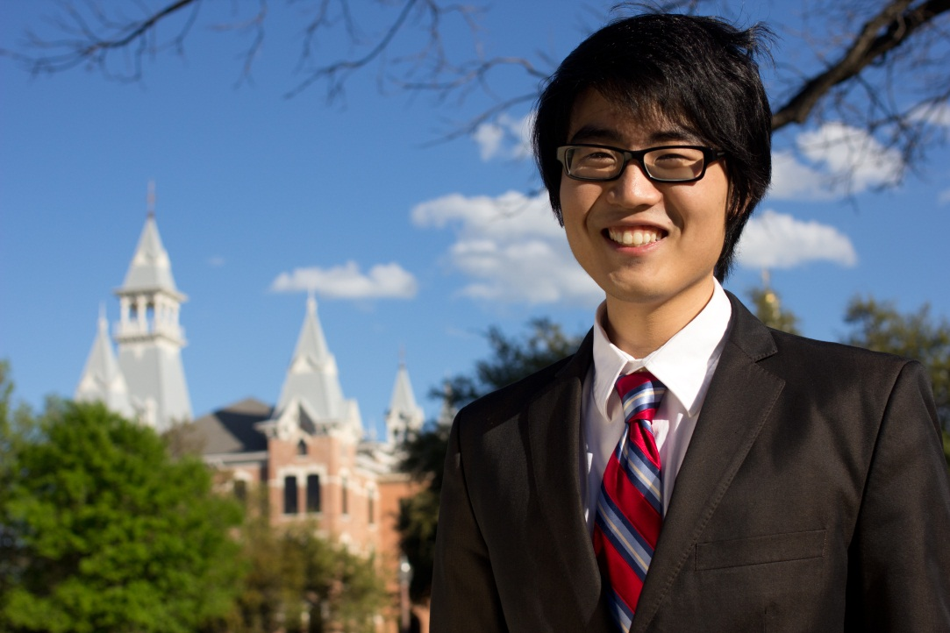

Brian shuts the door of the small room and stands authoritatively facing the eager smiles of his campaign team. The room is crowded with 12 of his closest supporters who sit elbow-to-elbow along the confining walls of the second-floor SUB study room. The doors are tightly shut to prevent potential eavesdroppers from gathering information on the strategy and platform for Internal Vice President nominee Brian Kim.

Brian, a junior political science major, begins his first campaign meeting for the 2012 Student Government Elections. He is running for Internal Vice President (IVP) and has assembled a skilled team of friends, peers, and fellow members of Student Government to assist him in a successful campaign.

The IVP position is the president of the Student Government senate. Student Government represents the voice of the student body. “We advocate and allocate,” he explains. Student Government allocates around $130 thousand a year to student organizations and campus events. They are responsible for funding Baylor’s biggest events such as Christmas on 5th Street and Dia Del Oso. The money used comes from the Student Government Allocation Fund, money that can requested by any on-campus organization. This year, Brian co-authored the Dia bill which allocated around $26 thousand to the day of festivities. “We basically funded the entertainment portion of Dia. About $20 thousand of that money was for the band,” says Brian referring to this year’s musical guest, Parachute.

The Student Senate exists as the legislative branch of Student Government and works to advocate on behalf of students. The senate meets every Thursday to vote on and discuss proposed legislation. Meetings are open to the public and can last as long as five hours when multiple legislations are on the agenda.

Brian has been a member of the student senate since his freshman year at Baylor. Working with a small team consisting of his shy roommate Chris and high school friend Meredith, Brian ran for freshman senator and won the position with the most votes of any senate candidate in the freshman class. Brian says, “I felt the need to serve the student body and make a difference at out university.” That is what the Student Senate does. They listen to concerns and ideas of students and turn them into recommendations for the university that are used to make changes and improvements. “There are many problems students are facing right now—tuition increase, parking problems, and financial aid,” lists Brian. These concerns are issues the senate addresses yearly.

“I'm supporting Brian Kim, because he is a great servant leader that has a full understanding of Senate and the operation and procedures of IVP,” says campaign member Dalleena Nguyen. The years of experience give Brian an advantage when competing for Student Government positions. He has formed lasting friendships with fellow senators, many of whom became indispensable assets to his campaign.

Brian hopes to use the position of IVP to bridge the gap between students and Student Government. He wants students at Baylor to know Student Government is an organization created to serve them. His goal aims to increase the presence of Student Government on campus and change the way students see their representatives. I want to establish a strong communication between Student Government representatives and our peers by providing an effective way for the student body to express their ideas and concerns to their representatives. want to establish a strong communication between Student Government representatives and our peers by providing an effective way for the student body to express their ideas and concerns to their representatives. “I want to establish a strong communication between Student Government representatives and our peers by providing an effective way for the student body to express their ideas and concerns,” Brian writes on his official campaign Facebook page.

Brian excitedly discusses his strategies to bridge the gap between Student Government and students, “We will be working closely with the IT department to begin sending out random sample surveys to students.” The surveys will be used to gather student opinion in a comfortable and anonymous way. “I also want to have open bipartisan forums where students can come in, listen, and give input,” Brian continues, “It’s just a room full of students, and we can talk about the issues.”

Brian believes improving the internal organization of Student Government will produce a more effective and efficient process in things such as allocating money. “I want to expedite the way we do things. The faster our organization gets things done, the happier the students are,” declares Brian.

In the small strategy room, Brian announces his campaign slogan to his huddled team, “BK Does it Your Way!” His slogan represents the role of IVP as a voice for the students and Brian’s responsibility to act as an advocate on their behalf.

Michael Lyssy, current IVP and a supporter of Brian Kim, worries the slogan will not strike the right chord with voters, and he suggests Brian consider a slogan with a more serious tone.

Although Brian takes the position of IVP very seriously, his slogan is a statement to his approachable and humorous personality. He wants to make the IVP a personable position that encourages students to speak openly about their university concerns, and he believes his slogan does that with simplicity and humor.

Brian is not new to the trials of election season. Last year, Brian ran for the same position of IVP and lost. Running under another unique slogan, “Licensed to Serve,” Brian channeled 007 to combat his opponents. Brian fought an exhausting battle of politics against Daniel Houston and Michael Lyssy. As the youngest candidate in the race, Brian knew he was the underdog; nonetheless, he successfully eliminated Daniel in the initial election and entered a run-off with incumbent Michael Lyssy.

The crushing announcement of Michael’s victory and his defeat on the cold, concrete steps of the Bill Daniel Student Union Building stifled Brian’s confidence momentarily. With 1,828 votes cast for Internal Vice President, Michael Lyssy received 60.61 percent of the votes over him. Brian recalls last year’s strenuous battle, “I put everything I had into that campaign, and when you invest so much time in something you really care about, it is hard to come out unsuccessful.”

Brian’s dedication and drive did not go unnoticed. He deservedly won the Excellence in Student Achievement Award, an award “designed to recognize students for outstanding contributions to student life while attending Baylor University.”

Fellow senators also took notice to Brian’s unwavering commitment. Dominic Edwards, freshman senator, says of Brian’s leadership, “In the Senate body, his presence and wisdom has always been a piece of admiration for me. As an incoming freshman viewing an upperclassman, I have looked up to Brian.”

After his loss in the 2011 IVP race, the senate voted Brian in as Pro Tempore of Senate for the 2011-2012 school year. The pro tempore substitutes as the Internal Vice President when the current IVP is absent. Brian says proudly, “I am also Vice Chair of the Executive Council and Director of All-University Committees.”

Although being Pro Tempore was an honor, Brian is back and ready to win the position he has prepared for since freshman year. The new year has brought a new confidence and a new campaign. Before dawn, the morning the campaign begins, Brian paints ruthlessly over last year’s slogan on his large wooden campaign signs and carries them to their respective campus locations for display.

The following weeks of campaigning are exciting, but mostly stressful. The electoral committee watches every move the candidates make. All campaign related signs, flyers, buttons, videos, and t-shirts must be approved before distribution. Even the candidates’ speeches are closely monitored. The strict guidelines ensure no electoral codes are broken by any candidate. Infractions are brought to Judicial Affairs where a ruling is made depending on the degree of the violation. Past candidates have been disqualified, such as 2010-2011 candidate Paul Baumgarndner, because of repeated violations. Brian runs a campaign without violation and is thankful when the end is near.

Finally, Dia Del Oso arrives. For many, Dia means food, music, friends, and this year, camels. For the candidates, Dia means a slow, anxious wait until the election votes are counted, finalized, and announced.

The Student Body President (SBP) and the External Vice President (EVP) candidates are nervously awaiting results as well. The SBP is the chief executive officer of Student Government, and the EVP is responsible for building relationships between Baylor and the Waco community. The IVP works closely with both student body officers.

Students gather at Fountain Mall waiting excitedly to see Parachute while the candidates crowd together alongside the stage making withdrawn conversation with their opponents. When the results are finalized, the announcer takes the stage and brings great news to some and bad news to others. Kelly Rippa takes SBP, Brianna Treadway takes EVP, and—after a pause that takes an eternity—the announcer reads, “Brian Kim wins Internal Vice President.”

Brian swallows the lump in his throat and releases the breath he’s been holding since last year’s loss. The battle for IVP is over, but the real battle is just beginning, fighting for the students at Baylor.

“A good Internal Vice President should be poised, diligent, trustworthy, and passionate. Brian Kim is the embodiment of all four characteristics,” declares Dominic. “Baylor University is soon to experience the best leadership it has ever seen on the senate floor.”